Test Case: tc005_SPX_Dev5_Crear_Requisicion_Spot_Con_FAD_Tipo_Cobro_Project
Step 1 - Enter username and password and click to button Enter: Credentials Entered
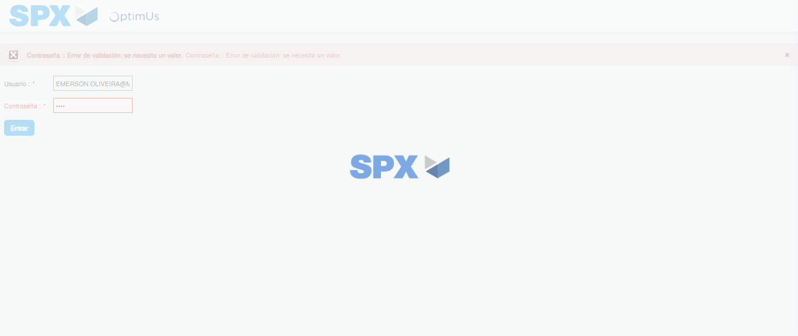Image file-name: QC_Testing-tc005_SPX_Dev5_Crear_Requisicion_Spot_Con_FAD_Tipo_Cobro_Project-1785975595897

Step 2 - Select to UEN and Access to Spot Buy Requisitions : UEN Correctly selected and Correct access
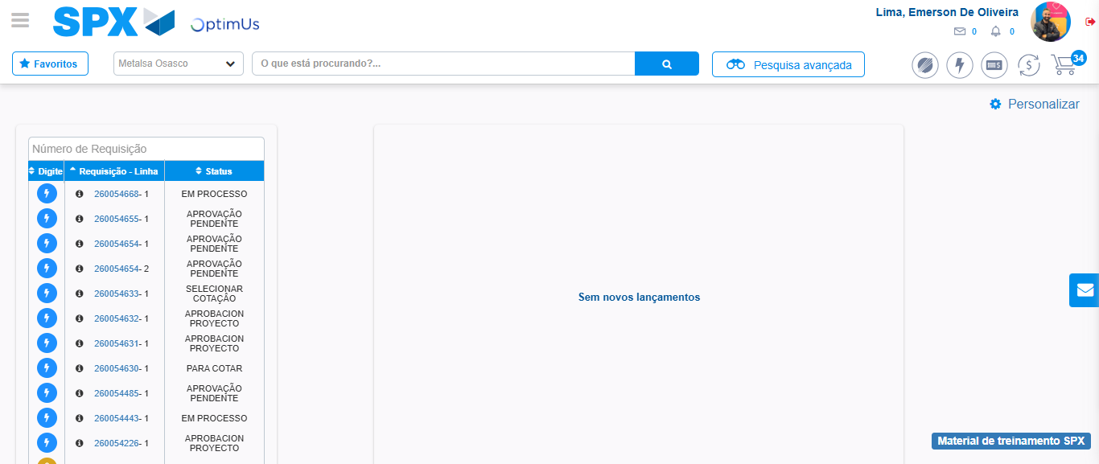Image file-name: QC_Testing-tc005_SPX_Dev5_Crear_Requisicion_Spot_Con_FAD_Tipo_Cobro_Project-1785975622500

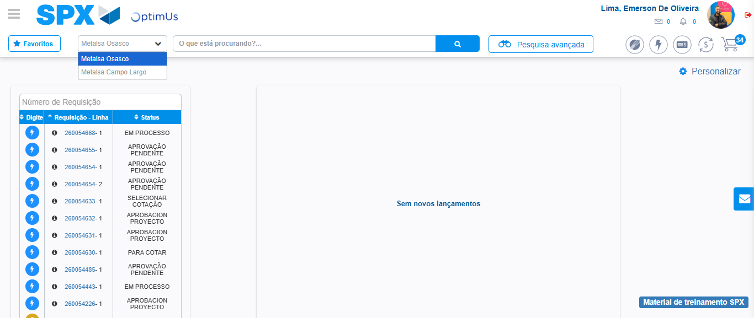Image file-name: QC_Testing-tc005_SPX_Dev5_Crear_Requisicion_Spot_Con_FAD_Tipo_Cobro_Project-1785975625109

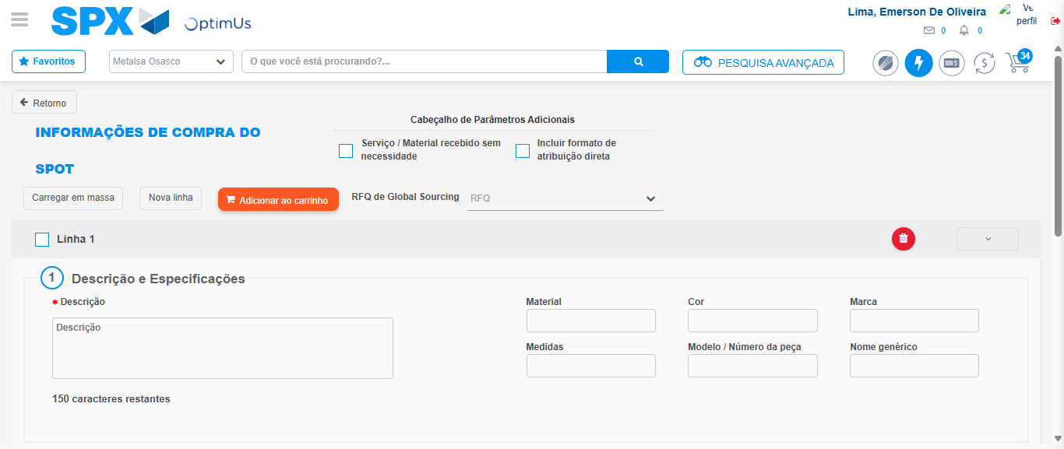Image file-name: QC_Testing-tc005_SPX_Dev5_Crear_Requisicion_Spot_Con_FAD_Tipo_Cobro_Project-1785975633836

Step 3 - Add FAD to Requisition: FAD Successfully Added
Image file-name: QC_Testing-tc005_SPX_Dev5_Crear_Requisicion_Spot_Con_FAD_Tipo_Cobro_Project-1785975634081

Image file-name: QC_Testing-tc005_SPX_Dev5_Crear_Requisicion_Spot_Con_FAD_Tipo_Cobro_Project-1785975634324

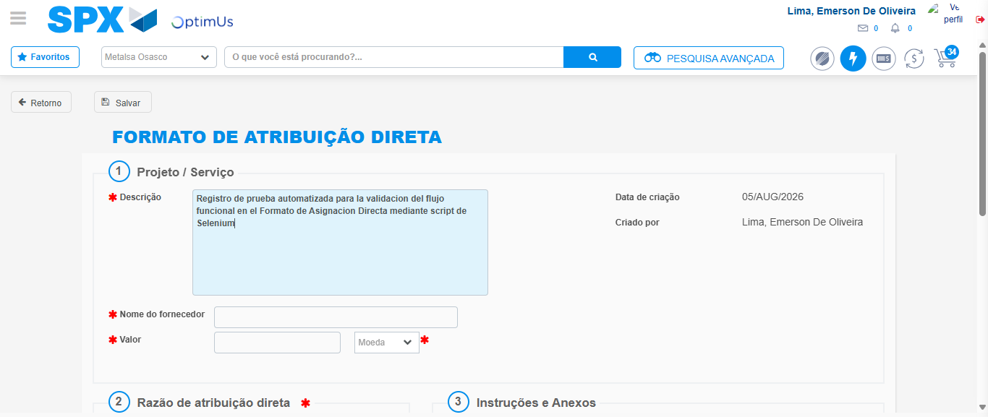Image file-name: QC_Testing-tc005_SPX_Dev5_Crear_Requisicion_Spot_Con_FAD_Tipo_Cobro_Project-1785975637417

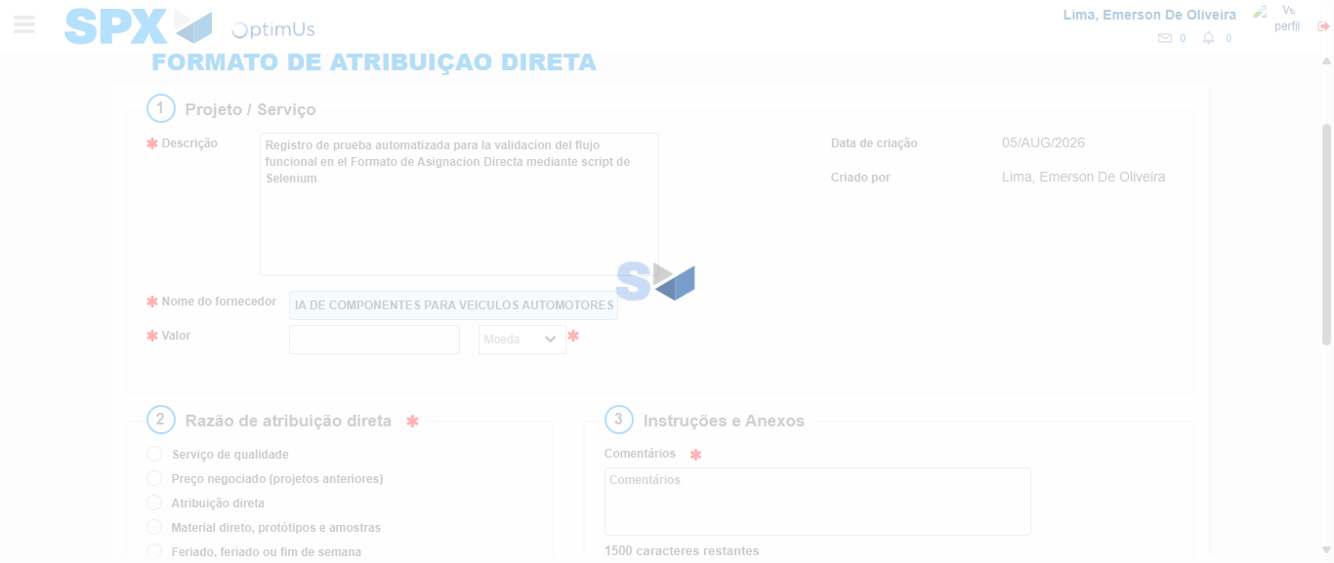Image file-name: QC_Testing-tc005_SPX_Dev5_Crear_Requisicion_Spot_Con_FAD_Tipo_Cobro_Project-1785975647707

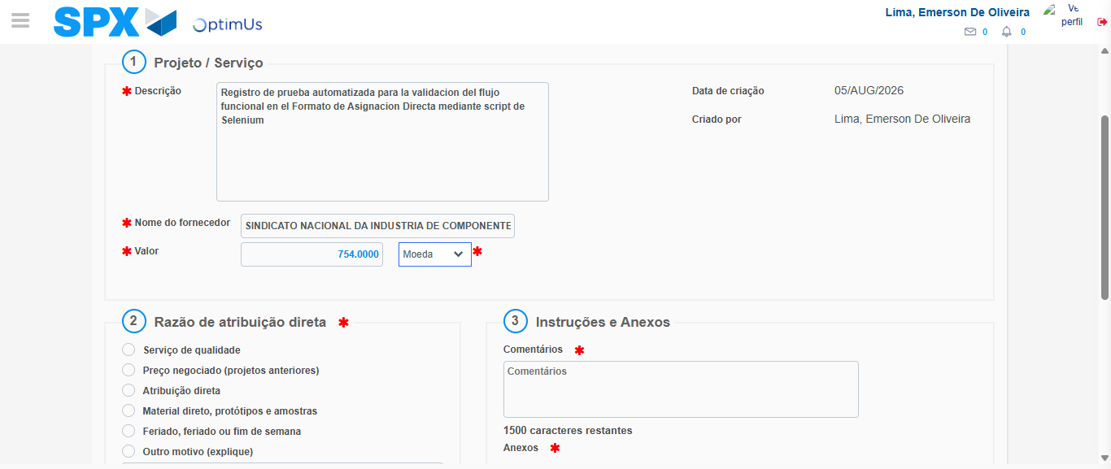Image file-name: QC_Testing-tc005_SPX_Dev5_Crear_Requisicion_Spot_Con_FAD_Tipo_Cobro_Project-1785975648132

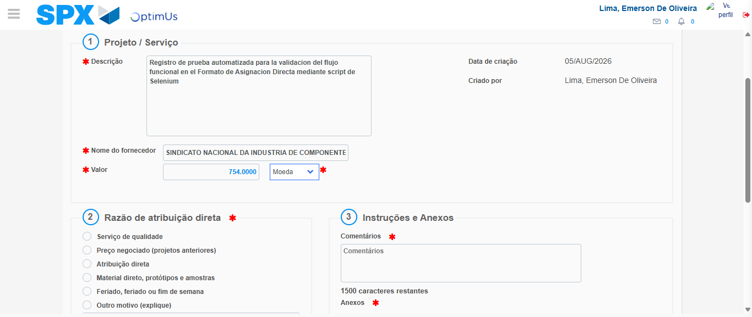Image file-name: QC_Testing-tc005_SPX_Dev5_Crear_Requisicion_Spot_Con_FAD_Tipo_Cobro_Project-1785975648324

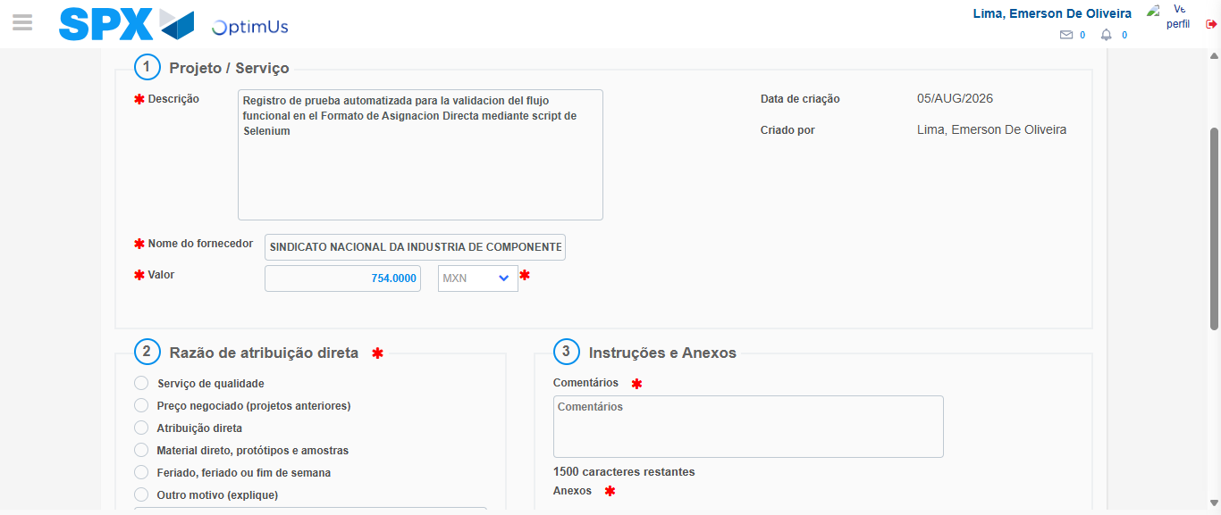Image file-name: QC_Testing-tc005_SPX_Dev5_Crear_Requisicion_Spot_Con_FAD_Tipo_Cobro_Project-1785975648732

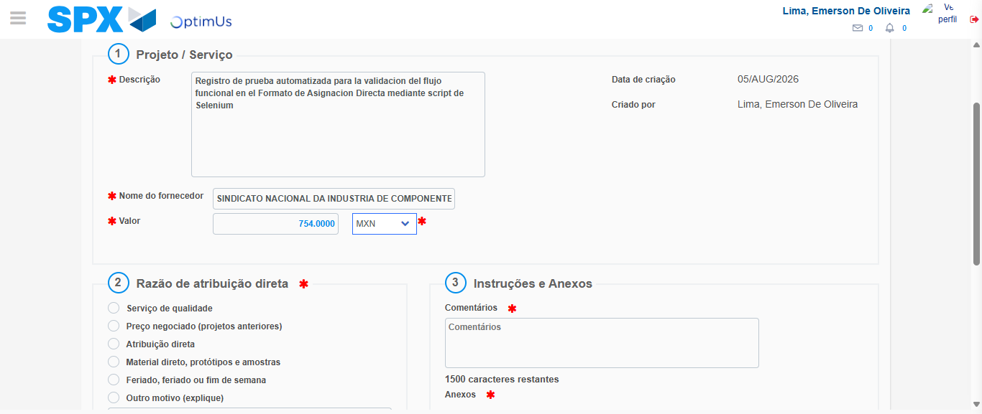Image file-name: QC_Testing-tc005_SPX_Dev5_Crear_Requisicion_Spot_Con_FAD_Tipo_Cobro_Project-1785975648938

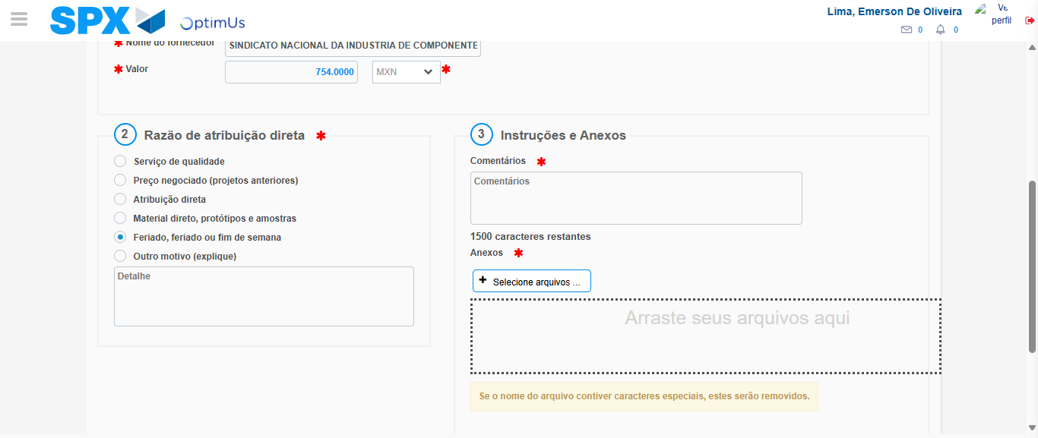Image file-name: QC_Testing-tc005_SPX_Dev5_Crear_Requisicion_Spot_Con_FAD_Tipo_Cobro_Project-1785975649900

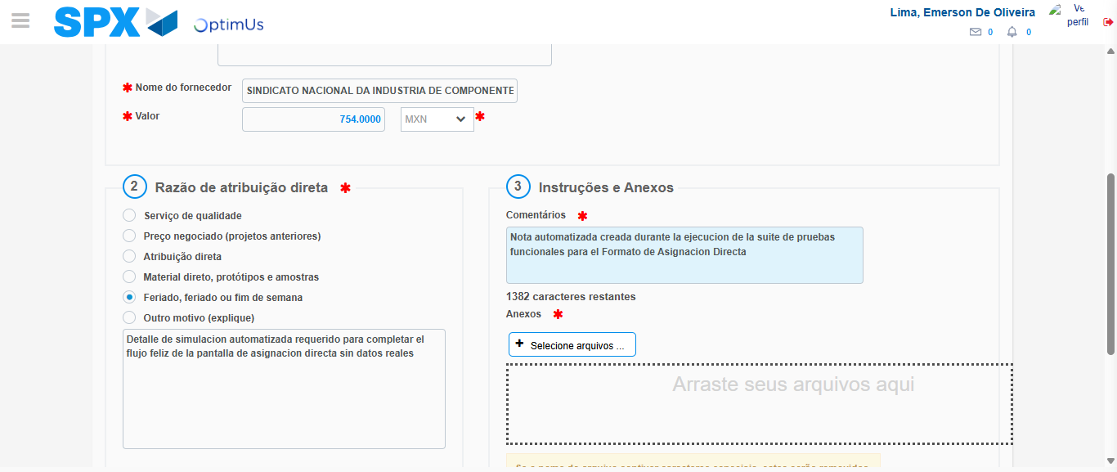Image file-name: QC_Testing-tc005_SPX_Dev5_Crear_Requisicion_Spot_Con_FAD_Tipo_Cobro_Project-1785975661346

Image file-name: QC_Testing-tc005_SPX_Dev5_Crear_Requisicion_Spot_Con_FAD_Tipo_Cobro_Project-1785975662283

Step 4 - Data Capture Spot Buy Requisition: Data captured correctly
Image file-name: QC_Testing-tc005_SPX_Dev5_Crear_Requisicion_Spot_Con_FAD_Tipo_Cobro_Project-1785975634081

Image file-name: QC_Testing-tc005_SPX_Dev5_Crear_Requisicion_Spot_Con_FAD_Tipo_Cobro_Project-1785975634324

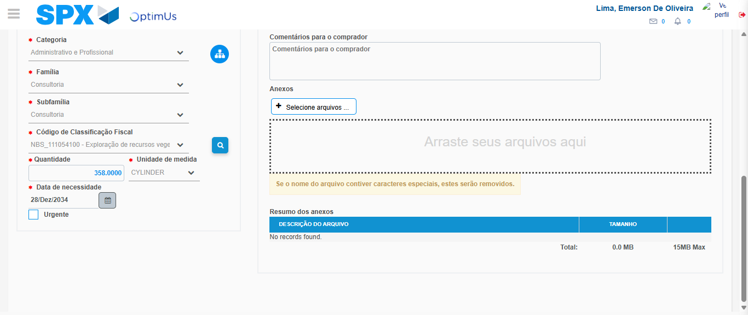Image file-name: QC_Testing-tc005_SPX_Dev5_Crear_Requisicion_Spot_Con_FAD_Tipo_Cobro_Project-1785975682448

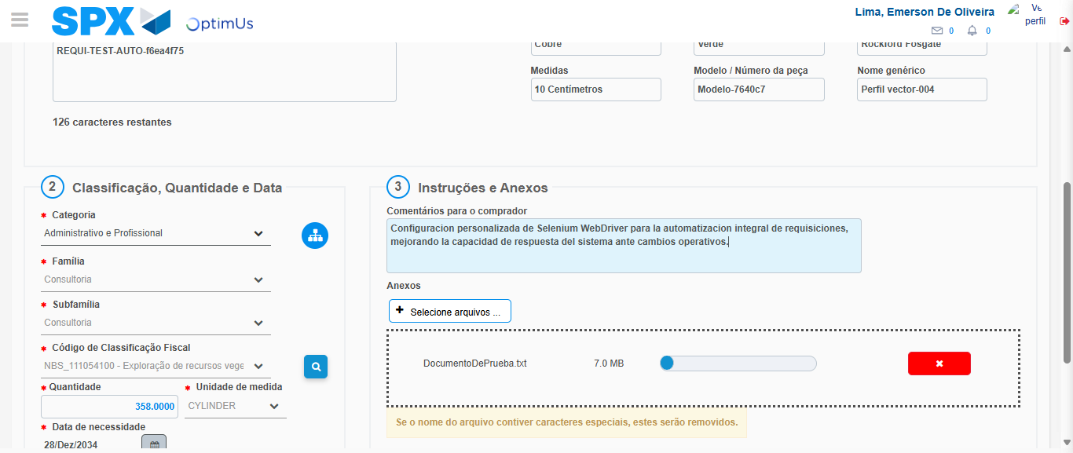Image file-name: QC_Testing-tc005_SPX_Dev5_Crear_Requisicion_Spot_Con_FAD_Tipo_Cobro_Project-1785975683506

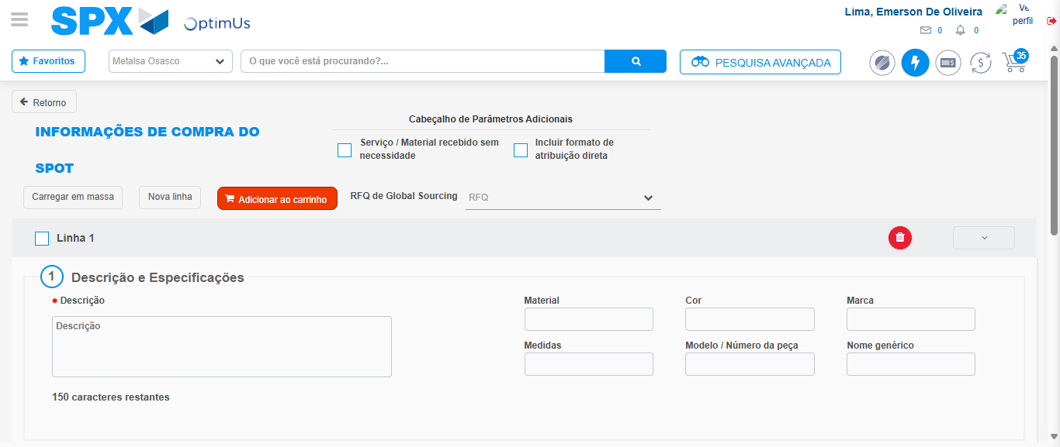Image file-name: QC_Testing-tc005_SPX_Dev5_Crear_Requisicion_Spot_Con_FAD_Tipo_Cobro_Project-1785975692561

Step 8 - Return to Main Page SPX : Return to Main Page SPX
Image file-name: QC_Testing-tc005_SPX_Dev5_Crear_Requisicion_Spot_Con_FAD_Tipo_Cobro_Project-1785975622500

Image file-name: QC_Testing-tc005_SPX_Dev5_Crear_Requisicion_Spot_Con_FAD_Tipo_Cobro_Project-1785975625109

Image file-name: QC_Testing-tc005_SPX_Dev5_Crear_Requisicion_Spot_Con_FAD_Tipo_Cobro_Project-1785975633836

Image file-name: QC_Testing-tc005_SPX_Dev5_Crear_Requisicion_Spot_Con_FAD_Tipo_Cobro_Project-1785975694826

Image file-name: QC_Testing-tc005_SPX_Dev5_Crear_Requisicion_Spot_Con_FAD_Tipo_Cobro_Project-1785975695070

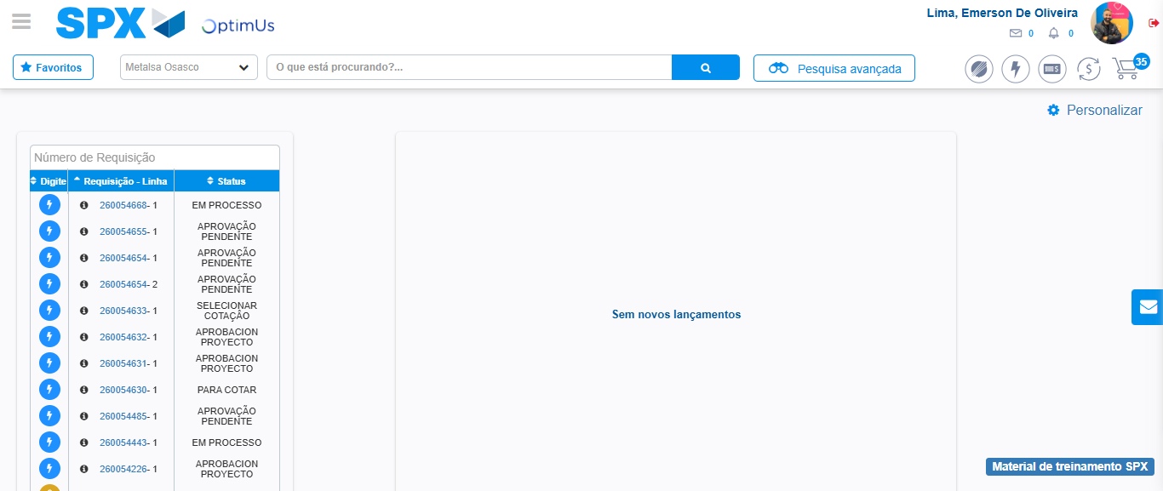Image file-name: QC_Testing-tc005_SPX_Dev5_Crear_Requisicion_Spot_Con_FAD_Tipo_Cobro_Project-1785975716301

Step 9 - Log Out : Log Out SPX
Image file-name: QC_Testing-tc005_SPX_Dev5_Crear_Requisicion_Spot_Con_FAD_Tipo_Cobro_Project-1785975716519

